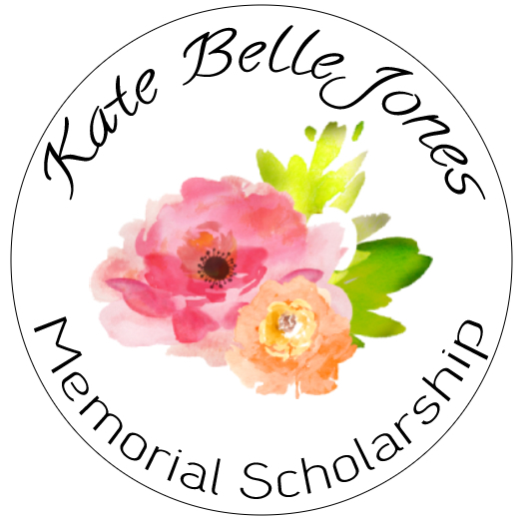

Kate Belle Jones was a young woman who impacted her community through service and steadfast commitment to her passion and goals. This scholarship was established in her memory to celebrate graduating seniors who also demonstrate these values. The recipients of this scholarship should demonstrate love and commitment to their school and community and exemplify a passion for creating a better world. The award amount is $1000 payable toward continuing education.

All applications should be complete and submitted by March 31, 2022.

Requirements for application:
1. Completed application form
2. Single Page Essay
3. Official High School Attendance Record or Transcript
4. 2 Letters of Recommendation (one from a teacher and one from a non-family member who can speak to your community involvement and character)
5. Previous enrollment at Tritt Elementary School

All documentation should be submitted electronically.
Letters of recommendation should be emailed to scholarship@trittfoundation.com by March 31, 2022.

