Exciting news! Pope students can take the YouScience assessment at any time from home. YouScience is a great way for students to learn more about themselves, explore high-demand careers that are a good fit for them, and gain a better understanding of how their unique talents are needed in the economy. Click the link below to learn more about YouScience and what it means for your student. https://www.youscience.com
YouScience is dedicated to helping answer questions that haunt students everywhere: “What should I major in?”, “What would I succeed in?”, “What do I want to do?” The YouScience Profile is designed to help students leverage their aptitudes, those natural abilities you were born with. The YouScience Profile is the only online platform that measures aptitudes and interests and then matches them to majors and careers that fit students best. Knowing one’s aptitudes empowers students to make some of life’s biggest decisions confidently! The online, scientific program will take students through a series of assessments and interest questions, designed to determine their results in the 14 key aptitudes utilized in the working world. The results include a review of the student’s personal strengths, suggested environments where they will succeed, detailed information on possible careers that match their skills and interests, majors that map to those careers, and much more.
Students can access their YouScience access code in their Naviance account (which they can be automatically logged into Naviance by logging into their Office 365 account and then going to www.cobbk12.org and clicking on the “Find it Fast” tab at the upper right of the page, and then clicking on “Naviance” in the drop down. Once in their Naviance account, they click on “About Me” in the upper right and then “My Account” and then look for the access code under “Nickname”. They then go to the YouScience account activation page using this URL: https://www.youscience.com/login/
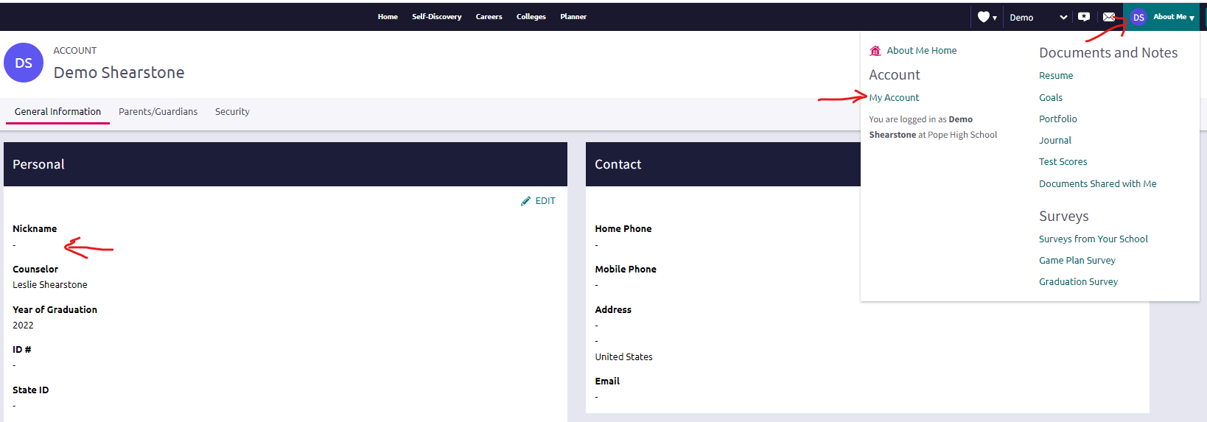
Results will be available 24 hours after the student completes the last assessment. For Students completing the YouScience Assessment on their own:
Here’s What to Expect:
- The assessment takes about 2 ½ hours to complete if you take the Core Assessment and the 2 Amplifier Assessments. There are 16 separate exercises, and most take 5-12 minutes to complete. The best time to take the assessment is when you are well rested so if you’ve had a long day, wait until tomorrow. If you choose to take only the Core Assessment the assessment time is reduced to 1 ½ hours.
- Make sure you’re in a quiet, comfortable place where you won’t be distracted by television, music, pets, or your cell phone. Please tell anyone who may be around you that you need quiet and privacy.
- For your results to be accurate, you’ll need to provide your honest effort – no calculators or cheats! Do the best you can.
- Some exercises will come easy; others may be difficult or even frustrating. Knowing what’s hard is just as important as knowing what comes naturally.
- To help you pace yourself we built in 10-minute breaks after some of the exercises. Take advantage of those breaks. You deserve them! It is even okay if you need to come back and finish the next day.
- Please make sure you don’t press the back button or close your browser during an active exercise. If you need extra breaks, take them in between exercises.
- Make sure you read the directions completely before beginning each exercise.
Technical Requirements:
- Use a desktop or laptop computer only. The YouScience Profile cannot be taken on a mobile or tablet device.
- Use one of the following browsers: Safari 7.0 or above, Firefox 38.0 or above, Chrome 42.0 or above, Internet Explorer 10 or above.
- Use a stable, high-speed Internet connection.
- If you’re using a wireless connection, please take precautions that your connection will not be interrupted during testing, as technical difficulties can decrease the accuracy of the results.
Utilizing Your Results:
Go to this page to find resource videos that will take you through your results and how to utilize them:
https://knowledgebase.youscience.com/scoir-results-walkthrough-videos

